检测报告

# 基本信息:

|  |  |
| --- | --- |
| 文件名 | IMG_20231201_151000.jpg |
| 检测时间 | 2025-03-26 14:22:15 |
| 检测状态 | 已完成: YOLO检测, 关键点检测, PointRend检测 |
| 数据类型 | 真实检测数据 |

# 原始图片:

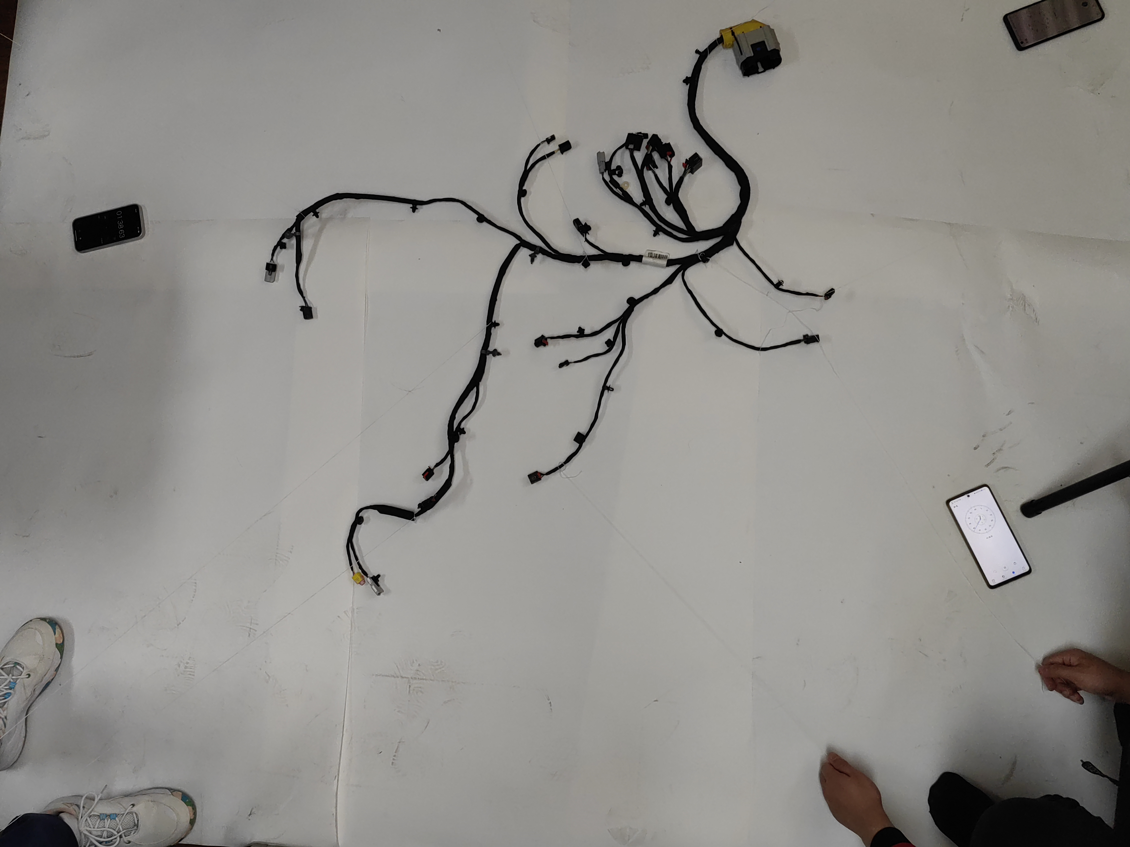

# 检测结果:

## YOLO检测结果

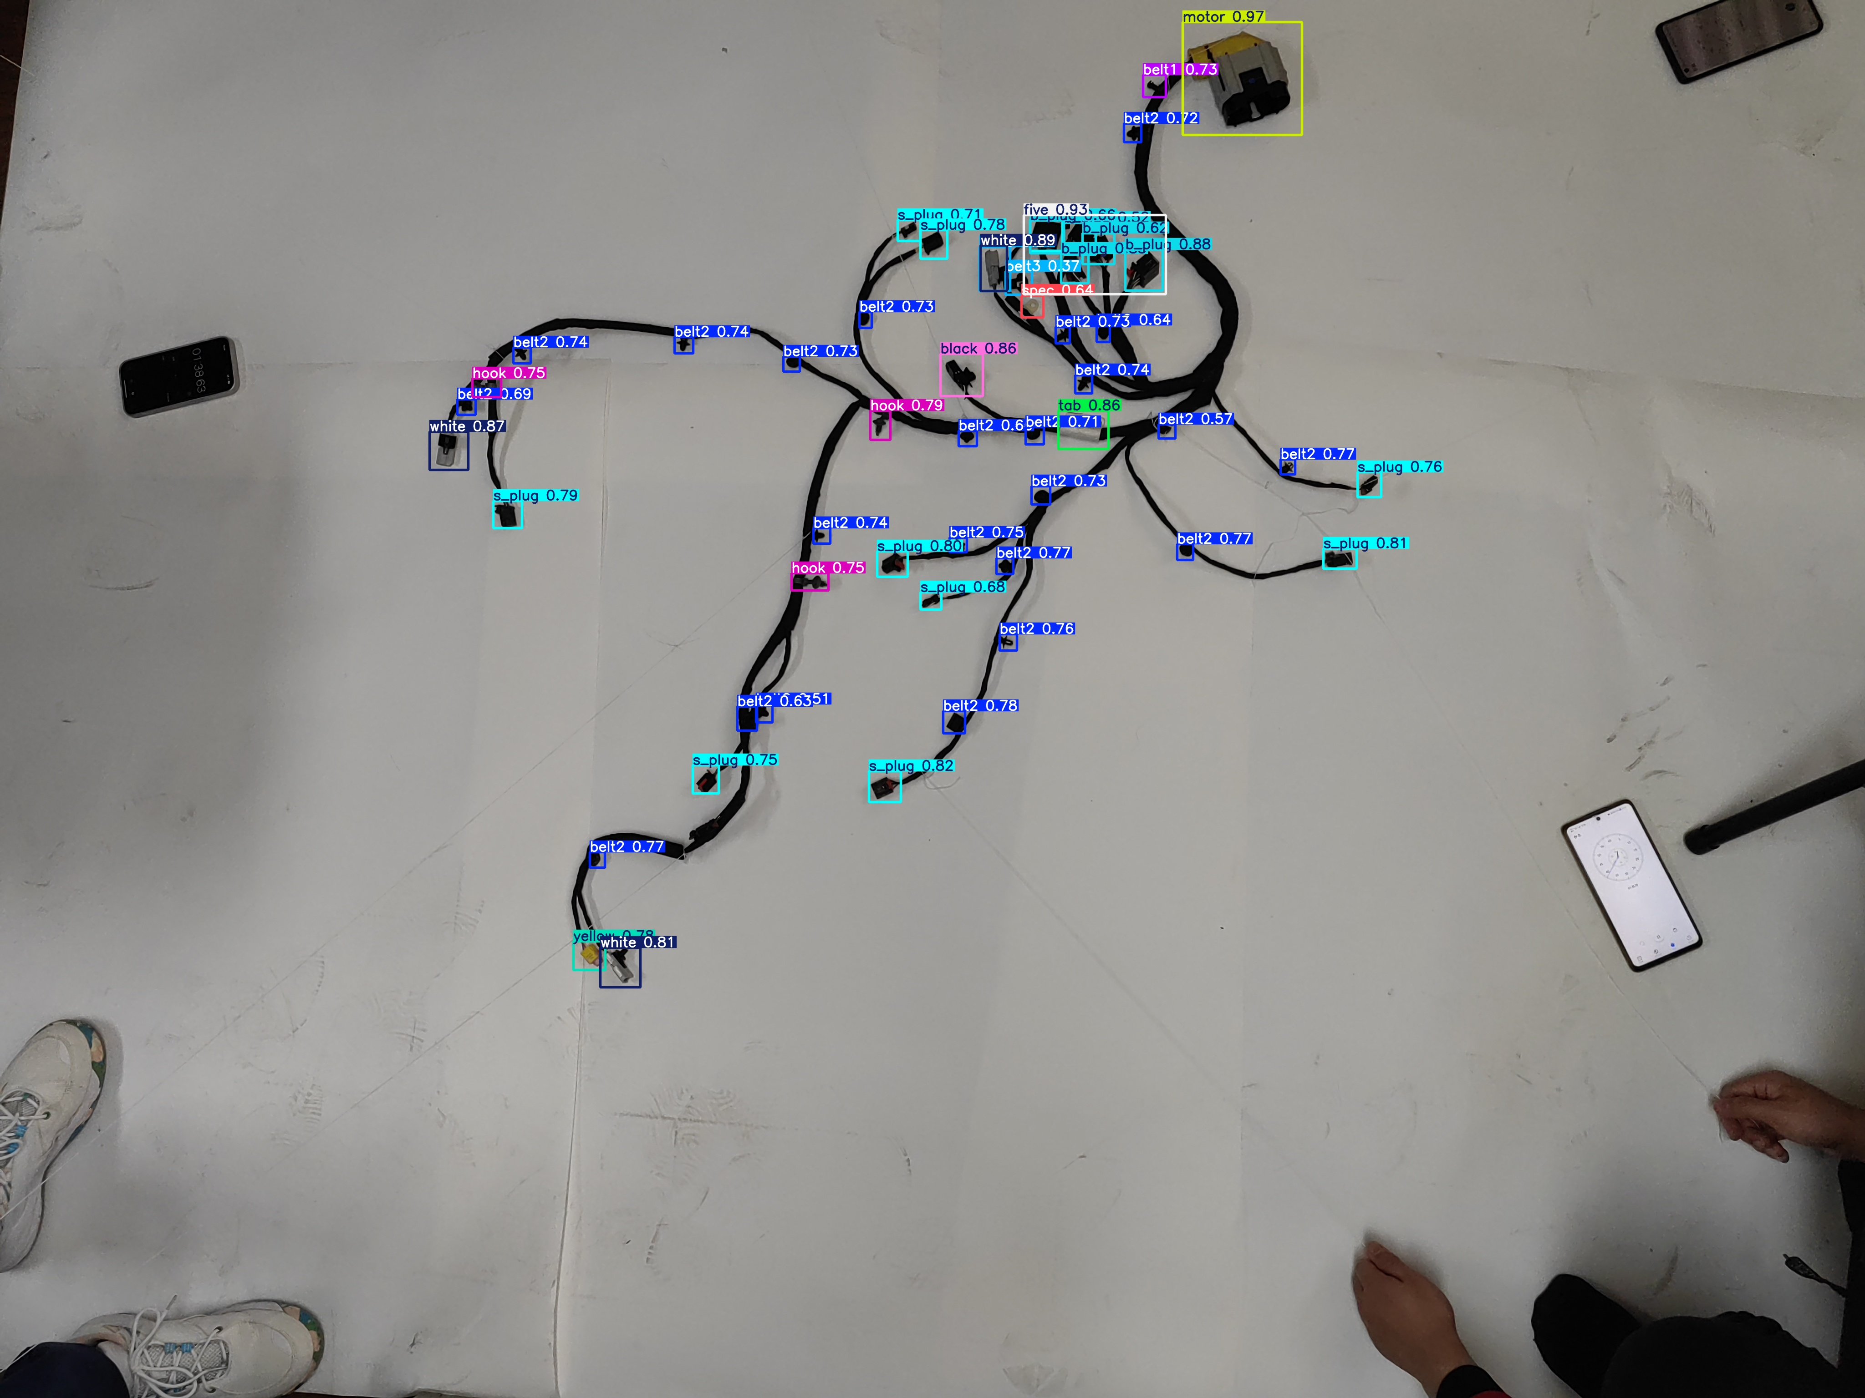

## 关键点检测结果

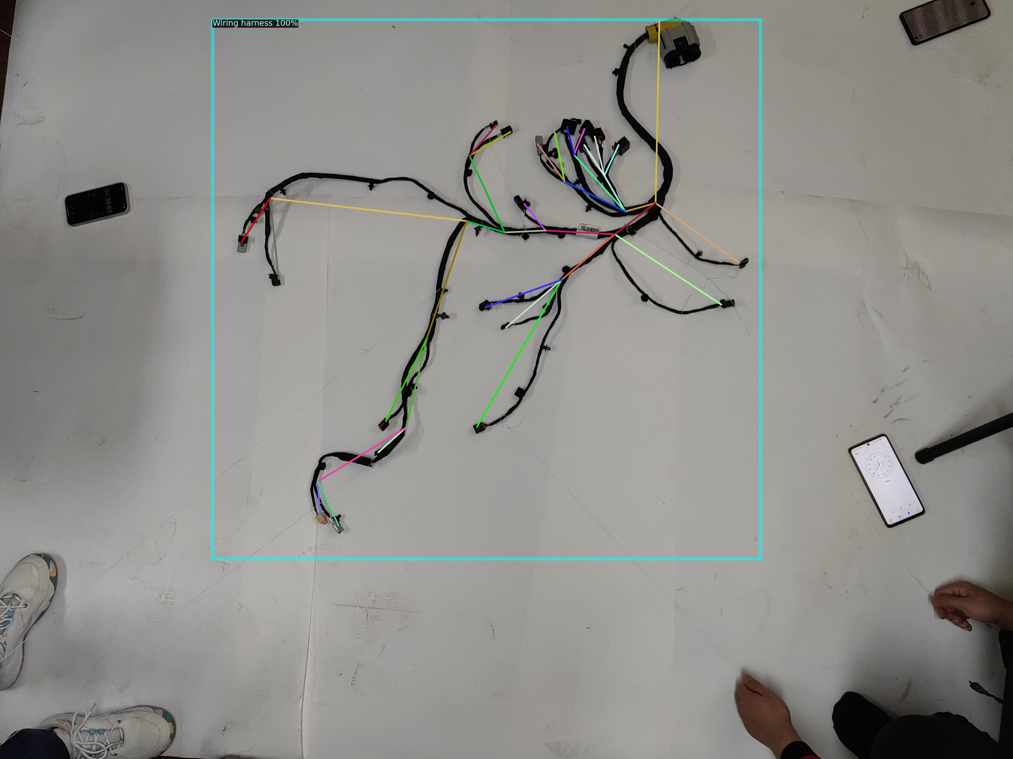

## PointRend检测结果

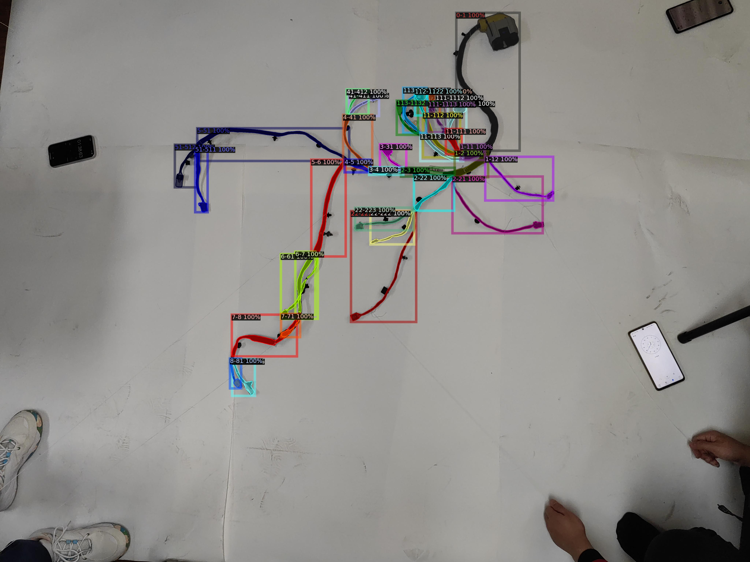

# YOLO检测结果:

|  |  |  |
| --- | --- | --- |
| **对象类型** | **置信度** | **边界框 (x1,y1,x2,y2)** |
| belt3 | 0.27 | (2151,542,2218,639) |
| s_plug | 0.28 | (2262,483,2333,551) |
| belt3 | 0.37 | (2208,596,2266,647) |
| belt2 | 0.51 | (1660,1547,1696,1587) |
| b_plug | 0.52 | (2336,489,2406,559) |
| belt2 | 0.57 | (2544,932,2581,963) |
| b_plug | 0.62 | (2377,512,2447,580) |
| belt2 | 0.63 | (1619,1552,1662,1605) |
| belt2 | 0.64 | (2408,714,2437,751) |
| spec | 0.64 | (2243,649,2291,697) |
| belt2 | 0.66 | (2105,946,2145,980) |
| b_plug | 0.66 | (2262,484,2336,556) |
| s_plug | 0.68 | (2021,1301,2067,1339) |
| belt2 | 0.69 | (1004,877,1044,911) |
| s_plug | 0.71 | (1971,483,2021,529) |
| belt2 | 0.71 | (2252,938,2292,976) |
| belt2 | 0.72 | (2468,271,2506,312) |
| belt2 | 0.73 | (2318,718,2349,754) |
| belt2 | 0.73 | (1720,783,1756,816) |
| belt2 | 0.73 | (2265,1068,2306,1108) |
| belt2 | 0.73 | (1887,685,1914,720) |
| belt1 | 0.73 | (2510,164,2560,213) |
| belt2 | 0.74 | (1786,1160,1823,1194) |
| belt2 | 0.74 | (1127,763,1165,798) |
| belt2 | 0.74 | (2361,824,2398,864) |
| belt2 | 0.74 | (1481,740,1522,776) |
| hook | 0.75 | (1738,1259,1819,1297) |
| belt2 | 0.75 | (2085,1181,2123,1213) |
| s_plug | 0.75 | (1521,1681,1578,1743) |
| hook | 0.75 | (1037,831,1100,872) |
| belt2 | 0.76 | (2195,1393,2233,1429) |
| s_plug | 0.76 | (2981,1037,3033,1092) |
| belt2 | 0.77 | (2812,1009,2844,1042) |
| belt2 | 0.77 | (2188,1226,2225,1261) |
| belt2 | 0.77 | (2585,1195,2620,1230) |
| belt2 | 0.77 | (1295,1872,1328,1906) |
| s_plug | 0.78 | (2021,505,2080,568) |
| belt2 | 0.78 | (2071,1562,2119,1611) |
| yellow | 0.78 | (1259,2068,1329,2131) |
| s_plug | 0.79 | (1083,1100,1146,1160) |
| hook | 0.79 | (1911,902,1955,966) |
| s_plug | 0.80 | (1926,1211,1993,1267) |
| s_plug | 0.81 | (2906,1205,2979,1249) |
| white | 0.81 | (1318,2082,1406,2169) |
| s_plug | 0.82 | (1908,1694,1978,1762) |
| b_plug | 0.85 | (2330,557,2390,622) |
| tab | 0.86 | (2324,902,2434,986) |
| black | 0.86 | (2065,777,2158,870) |
| white | 0.87 | (943,948,1028,1032) |
| b_plug | 0.88 | (2471,548,2553,638) |
| white | 0.89 | (2153,539,2211,639) |
| five | 0.93 | (2248,472,2560,646) |
| motor | 0.97 | (2597,48,2859,296) |

检测已执行，但详细数据不可用

# 人体关键点检测结果:

|  |  |  |  |
| --- | --- | --- | --- |
| **关键点** | **X坐标** | **Y坐标** | **置信度** |
| 鼻子 | 2666.18 | 85.49 | 1.06 |
| 左眼 | 2650.83 | 821.84 | 16.71 |
| 右眼 | 2485.77 | 948.40 | 13.41 |
| 左耳 | 2205.55 | 933.06 | 63.87 |
| 右耳 | 2040.50 | 940.73 | 29.05 |
| 左肩 | 1886.95 | 894.71 | 156.58 |
| 右肩 | 1725.73 | 1370.26 | 383.02 |
| 左肘 | 1641.29 | 1730.77 | 1.93 |
| 右肘 | 1284.30 | 1949.37 | 6.11 |
| 左手腕 | 977.22 | 979.08 | 19.89 |
| 右手腕 | 2527.99 | 856.36 | 85.43 |
| 左臀 | 2988.62 | 1063.45 | 3.41 |
| 右臀 | 2915.69 | 1232.20 | 7.86 |
| 左膝 | 2270.81 | 1132.49 | 67.06 |
| 右膝 | 2063.53 | 534.20 | 1.36 |
| 左脚踝 | 2005.95 | 507.36 | 196.14 |
| 右脚踝 | 2121.11 | 825.67 | 7.79 |

# PointRend检测结果:

|  |  |  |
| --- | --- | --- |
| **对象类型** | **置信度** | **区域位置** |
| 6-61 | 1.00 | 边界框: (1533,1389,1735,1742) |
| 113-1131 | 1.00 | 边界框: (2201,480,2329,726) |
| 11-112 | 1.00 | 边界框: (2309,616,2512,860) |
| 2-21 | 1.00 | 边界框: (2470,964,2963,1275) |
| 11-113 | 1.00 | 边界框: (2295,732,2529,880) |
| 113-1132 | 1.00 | 边界框: (2166,550,2282,736) |
| 8-81 | 1.00 | 边界框: (1255,1959,1317,2123) |
| 1-12 | 1.00 | 边界框: (2649,857,3021,1095) |
| 112-1121 | 1.00 | 边界框: (2319,487,2402,634) |
| 22-222 | 1.00 | 边界框: (2023,1153,2261,1335) |
| 6-7 | 1.00 | 边界框: (1613,1375,1721,1722) |
| 111-1113 | 1.00 | 边界框: (2338,556,2433,721) |
| 11-111 | 1.00 | 边界框: (2435,704,2523,843) |
| 0-1 | 1.00 | 边界框: (2492,69,2837,824) |
| 7-71 | 1.00 | 边界框: (1535,1715,1638,1842) |
| 1-2 | 1.00 | 边界框: (2482,824,2665,968) |
| 51-511 | 1.00 | 边界框: (1066,803,1134,1159) |
| 5-51 | 1.00 | 边界框: (1076,700,1906,880) |
| 22-223 | 1.00 | 边界框: (1938,1135,2257,1258) |
| 1-11 | 1.00 | 边界框: (2513,789,2649,874) |
| 51-512 | 1.00 | 边界框: (954,791,1081,1023) |
| 22-221 | 1.00 | 边界框: (1917,1153,2273,1760) |
| 4-5 | 1.00 | 边界框: (1881,872,2024,942) |
| 8-82 | 1.00 | 边界框: (1268,1962,1391,2164) |
| 112-1122 | 1.00 | 边界框: (2266,486,2335,630) |
| 5-6 | 1.00 | 边界框: (1700,872,1888,1401) |
| 7-8 | 1.00 | 边界框: (1265,1720,1621,1947) |
| 2-22 | 1.00 | 边界框: (2261,959,2479,1152) |
| 4-41 | 1.00 | 边界框: (1874,627,2032,920) |
| 111-1112 | 1.00 | 边界框: (2380,521,2448,693) |
| 3-4 | 1.00 | 边界框: (2016,913,2203,955) |
| 2-3 | 1.00 | 边界框: (2189,917,2483,965) |
| 3-31 | 1.00 | 边界框: (2074,789,2219,930) |
| 111-1111 | 1.00 | 边界框: (2444,554,2546,711) |
| 41-411 | 1.00 | 边界框: (1906,508,2069,633) |
| 41-412 | 1.00 | 边界框: (1893,488,2013,625) |

# 检测耗时:

|  |  |
| --- | --- |
| **检测类型** | **执行时间 (秒)** |
| YOLO检测 | 1.1361 |
| 关键点检测 | 8.7125 |
| PointRend检测 | 21.7925 |